A quantitative health impact assessment of urban greenspace and all-cause mortality across 1,041 global cities

Greta K. Martin¹, Jennifer D. Stowell², Patrick L. Kinney², Susan C. Anenberg¹

¹The George Washington University Milken Institute of Public Health, Washington, DC
²Boston University School of Public Health, Boston, MA

SUPPLEMENTAL MATERIAL

Contents of this file

List S1
Figures S1-S7
Table S1-S2

List S1. Countries not represented in analysis.

- Andorra
- Antigua and Barbuda
- Eswatini (former Swaziland)
- Dominica
- Grenada
- Holy See
- Kiribati
- Liechtenstein
- Marshall Islands
- Micronesia (Federated States of)
- Nauru
- Palau
- Saint Kitts and Nevis
- Saint Lucia
- Saint Vincent and the Grenadines
- Samoa
- San Marino
- Seychelles
- State of Palestine
- Tonga
- Tuvalu
- Vanuatu

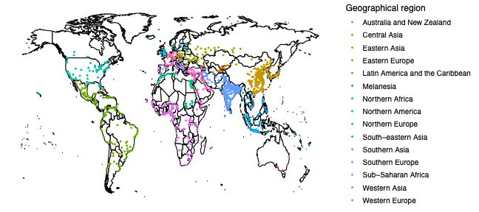
Figure S1. Map of the 1,041 global cities by United Nations Statistical Division sub-regional classifications.
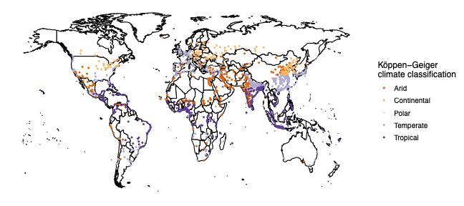
Figure S2. Map of the 1,041 global cities by Köppen-Geiger climate classification.

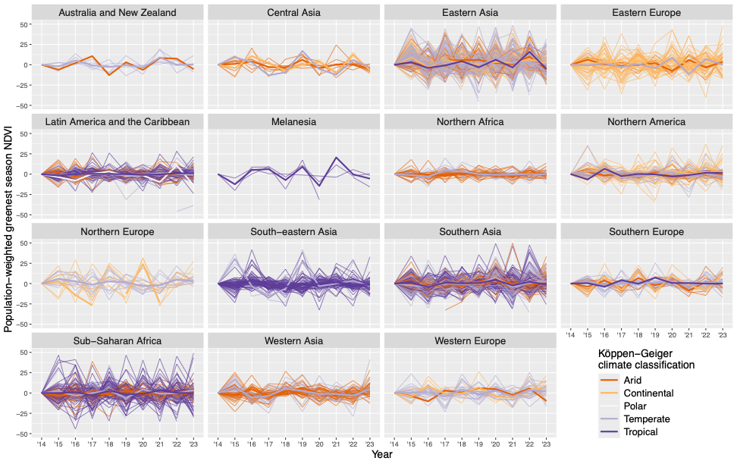
Figure S3. Percent change from previous year in city average annual population-weighted greenest season Normalized Difference Vegetation Index (NDVI) from 2014-2023 by geographic region. Thin lines represent individual cities, and thick lines show the average NDVI percent change for all cities, colored by climate classification.
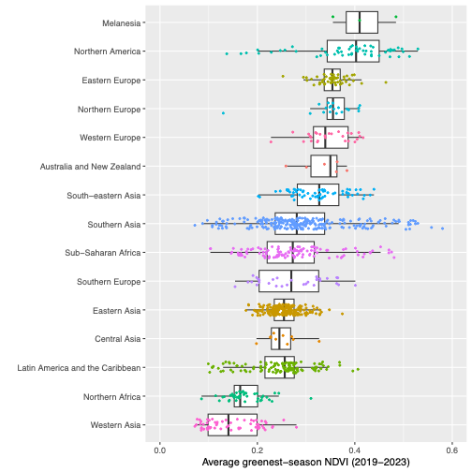
Figure S4. Average 2019-2023 city-level population-weighted greenest season Normalized Difference Vegetation Index (NDVI), by geographic region.
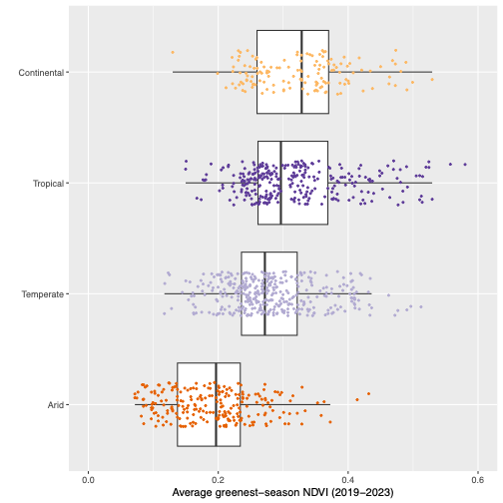
Figure S5. Average 2019-2023 city-level population-weighted greenest season Normalized Difference Vegetation Index, by Köppen-Geiger climate classification. One city classified as Polar was dropped (El Alto, Bolivia, 0.107).

Changes in NDVI from 2014-2018 to 2019-2023 were associated with an estimated average of 3 fewer (95% CI: 1, 6) deaths globally, and a median change of 2 more (95% CI: 1, 4) deaths. Large negative outliers including Bejing, China; Moscow, Russia; Shanghai, China; and Delhi, India are responsible for the change in signs between the mean and median values. Regional and climate patterns mirror those scaled to population. However, the absolute results have much wider distributions driven by cities with large populations.
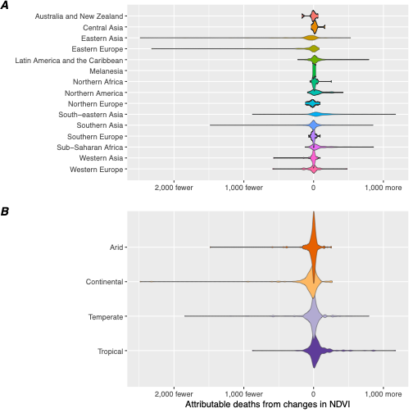

Figure S6. Associated changes in city-level mortality from changes in average population-weighted peak season Normalized Difference Vegetation Index from 2014-2018 to 2019-2023 to the 2020 population, by geographical region (panel A) and climate classification (panel B). One city classified as “Polar” was dropped from panel B (El Alto, Bolivia, 90 more deaths).
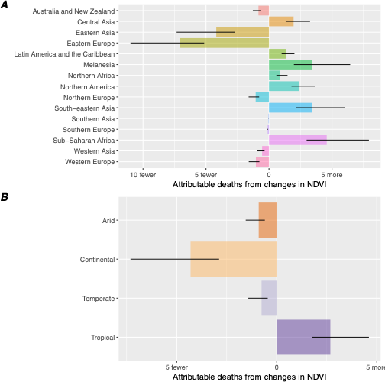

Figure S7. Total associated changes in deaths per 100,000 from changes in average population-weighted peak season Normalized Difference Vegetation Index from 2014-2018 to 2019-2023 to the 2020 population, by region (panel A) and climate classification (panel B). One city classified as “Polar” was dropped from panel B (El Alto, Bolivia, 4.78 (95% CI: 3.11, 8.51) more deaths per 100,000 population). The black bars represent the 95% confidence intervals, considering measured error in the mortality and risk ratio estimates.

Table S1. Total change in deaths in absolute and population-standardized terms from changes in in average population-weighted peak season Normalized Difference Vegetation Index from 2014-2018 to 2019-2023 in the 2020 population, by region.
Region | Population (2020) | Change in mortality | 95% CI absolute |  |  | Change in mortality (per 100,000) | 95% CI  (per 100,000)
Region | Population (2020) | Change in mortality | lb | ub |  | Change in mortality (per 100,000) | lb | ub
Australia and New Zealand | 12345979 | -103 | -159 |  | -76 | -0.84 | -1.28 | -0.62
Central Asia | 12976956 | 253 | 172 |  | 423 | 1.95 | 1.32 | 3.26
Eastern Asia | 492132074 | -20593 | -36095 |  | -13269 | -4.18 | -7.33 | -2.70
Eastern Europe | 64369399 | -4540 | -7078 |  | -3311 | -7.05 | -11.00 | -5.14
Latin America and the Caribbean | 229040750 | 3066 | 2294 |  | 4623 | 1.34 | 1.00 | 2.02
Melanesia | 652835 | 22 | 13 |  | 42 | 3.39 | 1.98 | 6.45
Northern Africa | 78336973 | 690 | 458 |  | 1152 | 0.88 | 0.58 | 1.47
Northern America | 140358784 | 3362 | 2503 |  | 5100 | 2.40 | 1.78 | 3.63
Northern Europe | 28851881 | -305 | -467 |  | -226 | -1.06 | -1.62 | -0.78
South-eastern Asia | 202014534 | 6951 | 4383 |  | 12186 | 3.44 | 2.17 | 6.03
Southern Asia | 467009884 | -194 | -209 |  | -131 | -0.04 | -0.04 | -0.03
Southern Europe | 38150645 | -41 | -62 |  | -30 | -0.11 | -0.16 | -0.08
Sub-Saharan Africa | 199295623 | 9135 | 5953 |  | 15806 | 4.58 | 2.99 | 7.93
Western Asia | 111143374 | -606 | -1069 |  | -392 | -0.55 | -0.96 | -0.35
Western Europe | 41372890 | -430 | -665 |  | -315 | -1.04 | -1.61 | -0.76

Table S2. Total change in deaths in absolute and population-standardized terms from changes in in average population-weighted peak season Normalized Difference Vegetation Index from 2014-2018 to 2019-2023 in the 2020 population, by climate classification.

Climate Classification | Population (2020) | Change in mortality | 95% CI absolute |  |  | Change in mortality (per 100,000) | 95% CI  (per 100,000)
Climate Classification | Population (2020) | Change in mortality | lb | ub |  | Change in mortality (per 100,000) | lb | ub
Arid | 437077498 | -3942 | -6777 |  | -2604 | -0.90 | -1.55 | -0.60
Continental | 253600401 | -10919 | -18535 |  | -7307 | -4.31 | -7.31 | -2.88
Polar | 1885470 | 90 | 59 |  | 160 | 4.78 | 3.11 | 8.51
Temperate | 778051544 | -5907 | -11055 |  | -3509 | -0.76 | -1.42 | -0.45
Tropical | 647437668 | 17345 | 11309 |  | 29813 | 2.68 | 1.75 | 4.60

